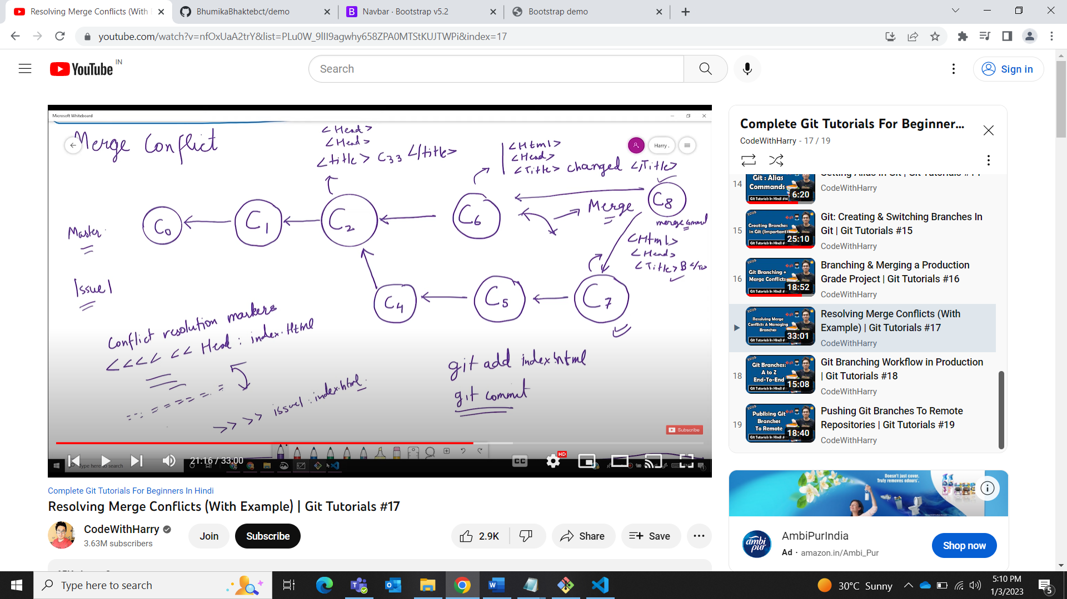

Bhumika.Bhakte@XIPL9760 MINGW64 /d/Git

$ git status

fatal: not a git repository (or any of the parent directories): .git

Bhumika.Bhakte@XIPL9760 MINGW64 /d/Git

$ git init

Initialized empty Git repository in D:/Git/.git/

Bhumika.Bhakte@XIPL9760 MINGW64 /d/Git (master)

$ git add .

warning: adding embedded git repository: MyWebsite

hint: You've added another git repository inside your current repository.

hint: Clones of the outer repository will not contain the contents of

hint: the embedded repository and will not know how to obtain it.

hint: If you meant to add a submodule, use:

hint:

hint: git submodule add <url> MyWebsite

hint:

hint: If you added this path by mistake, you can remove it from the

hint: index with:

hint:

hint: git rm --cached MyWebsite

hint:

hint: See "git help submodule" for more information.

Bhumika.Bhakte@XIPL9760 MINGW64 /d/Git (master)

$ git rm --cached MyWebsite

error: the following file has staged content different from both the

file and the HEAD:

MyWebsite

(use -f to force removal)

Bhumika.Bhakte@XIPL9760 MINGW64 /d/Git (master)

$ git add .

Bhumika.Bhakte@XIPL9760 MINGW64 /d/Git (master)

$ git commit -m "initial commit"

[master (root-commit) 35d27a7] initial commit

12 files changed, 9 insertions(+)

create mode 100644 .gitignore

create mode 160000 MyWebsite

create mode 100644 commands.docx

create mode 100644 db.accdb

create mode 100644 first_renamed.txt

create mode 100644 garbage/error - Copy (2).log

create mode 100644 garbage/error - Copy (3).log

create mode 100644 garbage/error - Copy.log

create mode 100644 garbage/error.log

create mode 100644 index.txt

create mode 100644 myexcel.xlsx

create mode 100644 static/dir/xyz.docx

Bhumika.Bhakte@XIPL9760 MINGW64 /d/Git (master)

$ git add .

Bhumika.Bhakte@XIPL9760 MINGW64 /d/Git (master)

$ git commit -m "added index.html"

[master 7fa2260] added index.html

1 file changed, 12 insertions(+)

create mode 100644 index.html

Bhumika.Bhakte@XIPL9760 MINGW64 /d/Git (master)

$ git status

On branch master

nothing to commit, working tree clean

Bhumika.Bhakte@XIPL9760 MINGW64 /d/Git (master)

$ git status

On branch master

Changes not staged for commit:

(use "git add <file>..." to update what will be committed)

(use "git restore <file>..." to discard changes in working directory)

modified: index.html

no changes added to commit (use "git add" and/or "git commit -a")

Bhumika.Bhakte@XIPL9760 MINGW64 /d/Git (master)

$ git add .

Bhumika.Bhakte@XIPL9760 MINGW64 /d/Git (master)

$ git commit -m "title 1"

[master 264b86a] title 1

1 file changed, 1 insertion(+), 1 deletion(-)

Bhumika.Bhakte@XIPL9760 MINGW64 /d/Git (master)

$ git status

On branch master

Changes not staged for commit:

(use "git add <file>..." to update what will be committed)

(use "git restore <file>..." to discard changes in working directory)

modified: index.html

no changes added to commit (use "git add" and/or "git commit -a")

Bhumika.Bhakte@XIPL9760 MINGW64 /d/Git (master)

$ git add .

Bhumika.Bhakte@XIPL9760 MINGW64 /d/Git (master)

$ git commit -m "title 2"

[master 2a889e0] title 2

1 file changed, 1 insertion(+), 1 deletion(-)

Bhumika.Bhakte@XIPL9760 MINGW64 /d/Git (master)

$ git status

On branch master

nothing to commit, working tree clean

Bhumika.Bhakte@XIPL9760 MINGW64 /d/Git (master)

$ git checkout -b issue1

Switched to a new branch 'issue1'

Bhumika.Bhakte@XIPL9760 MINGW64 /d/Git (issue1)

$ git commit -a -m "issue1 title 2"

[issue1 da1c912] issue1 title 2

1 file changed, 1 insertion(+), 1 deletion(-)

Bhumika.Bhakte@XIPL9760 MINGW64 /d/Git (issue1)

$ git commit -a -m "issue1 title 3 c5"

[issue1 77250a5] issue1 title 3 c5

1 file changed, 1 insertion(+), 1 deletion(-)

Bhumika.Bhakte@XIPL9760 MINGW64 /d/Git (issue1)

$ git status

On branch issue1

nothing to commit, working tree clean

Bhumika.Bhakte@XIPL9760 MINGW64 /d/Git (issue1)

$ git commit -a -m "issue1 title 3 c7"

[issue1 4762555] issue1 title 3 c7

1 file changed, 1 insertion(+), 1 deletion(-)

Bhumika.Bhakte@XIPL9760 MINGW64 /d/Git (issue1)

$ git status

On branch issue1

nothing to commit, working tree clean

Bhumika.Bhakte@XIPL9760 MINGW64 /d/Git (issue1)

$ git checkout master

Switched to branch 'master'

Bhumika.Bhakte@XIPL9760 MINGW64 /d/Git (master)

$ git commit -a -m "changed title 3 c6"

[master 283f272] changed title 3 c6

1 file changed, 1 insertion(+), 1 deletion(-)

Bhumika.Bhakte@XIPL9760 MINGW64 /d/Git (master)

$ git merge issue1

Auto-merging index.html

CONFLICT (content): Merge conflict in index.html

Automatic merge failed; fix conflicts and then commit the result.

Bhumika.Bhakte@XIPL9760 MINGW64 /d/Git (master|MERGING)

$ git status

On branch master

You have unmerged paths.

(fix conflicts and run "git commit")

(use "git merge --abort" to abort the merge)

Unmerged paths:

(use "git add <file>..." to mark resolution)

both modified: index.html

no changes added to commit (use "git add" and/or "git commit -a")

Bhumika.Bhakte@XIPL9760 MINGW64 /d/Git (master|MERGING)

$ git add index.html

Bhumika.Bhakte@XIPL9760 MINGW64 /d/Git (master|MERGING)

$ git status

On branch master

All conflicts fixed but you are still merging.

(use "git commit" to conclude merge)

Changes to be committed:

modified: index.html

Bhumika.Bhakte@XIPL9760 MINGW64 /d/Git (master|MERGING)

$ git commit -m "merged issue1"

[master 961d7a0] merged issue1

Bhumika.Bhakte@XIPL9760 MINGW64 /d/Git (master)

$ git log

commit 961d7a0b6edf4369980117a5f15166ef79822877 (HEAD -> master)

Merge: 283f272 4762555

Author: Bhumika Bhakte <Bhumika.Bhakte@blueconchtech.com>

Date: Tue Jan 3 17:14:20 2023 +0530

merged issue1

commit 283f27215aeb2805fb2f50bb4192a00da13d600e

Author: Bhumika Bhakte <Bhumika.Bhakte@blueconchtech.com>

Date: Tue Jan 3 17:12:05 2023 +0530

changed title 3 c6

commit 47625554a32f84ece20e2dd75181da8d6c72819e (issue1)

Author: Bhumika Bhakte <Bhumika.Bhakte@blueconchtech.com>

Date: Tue Jan 3 17:10:36 2023 +0530

issue1 title 3 c7

commit 77250a548eb8647826381ba3dd1e3b8a153f5387

Author: Bhumika Bhakte <Bhumika.Bhakte@blueconchtech.com>

Date: Tue Jan 3 17:09:55 2023 +0530

Bhumika.Bhakte@XIPL9760 MINGW64 /d/Git (master)

$